Test 4(for loop)

Q1

//range of factors

#include<stdio.h>

void main(){

int s,e;

printf("Enter the start:");

scanf("%d",&s);

printf("Enter the end:");

scanf("%d",&e);

//outer for loop for each ele

for(int i=s;i<=e;i++){

//

printf("factors of %d:\t",i);

for(int j=1;j<=i;j++)

{

if(i%j==0){

printf("%d\t",j);

}

}

printf("\n");

}//end of outer loop

}

Op

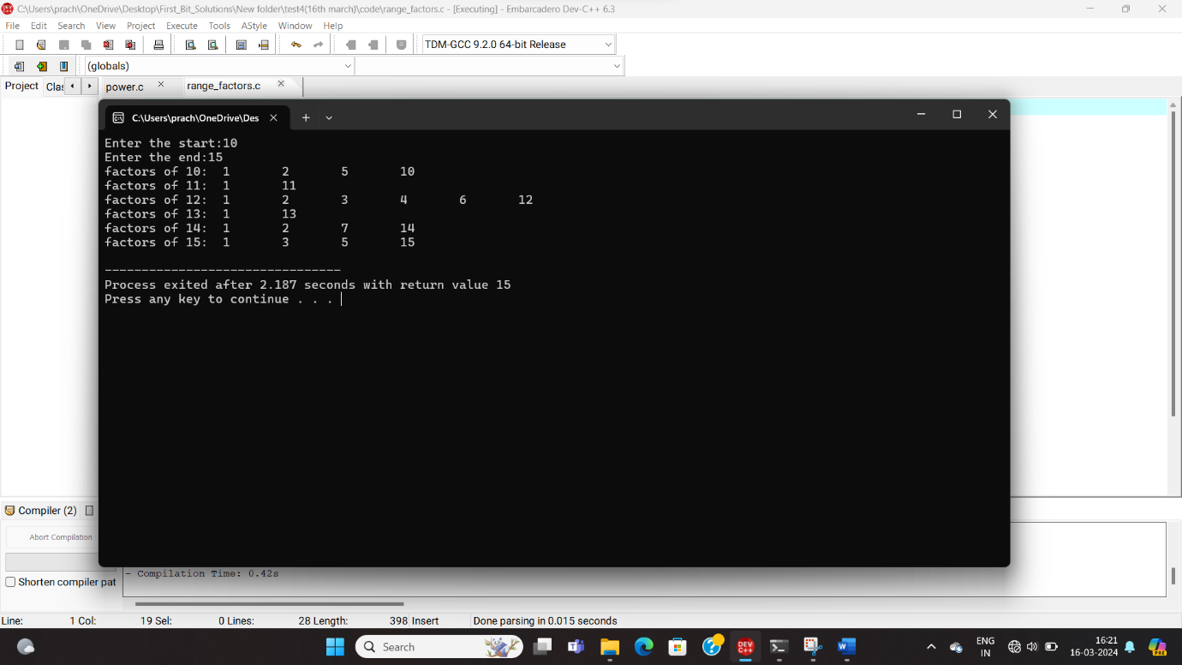

Q2

//power

#include<stdio.h>

void main(){

int num,power,res=1;

printf("Enter the num:");

scanf("%d",&num);

printf("Enter the power:");

scanf("%d",&power);

int p=power;

while(power!=0){

res=res\*num;

power--;

}

printf("%d to the power %d is %d",num,p,res);

}

Op

